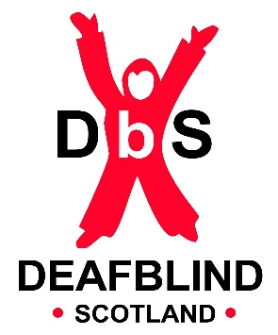

Seen and Heard: An outline of the need to define deafblindness as a unique disability within Scotland

[Andrena McMenemy, Isabella Goldie, Jonathan Reid, Professor John Ravenscroft, Angela Bonomy, John Whitfield]

23 January 2023

Deafblindness is a complex disability, requiring dedicated, multi-disciplinary services uniformly offered across the country. Although prevalence rates are low compared to some conditions they are rising and are higher than have often been understood with around 34,000 people in Scotland affected as outlined in Appendix 1. By using international context and giving examples of good practice with regard to defining deafblindness, this paper will demonstrate the need, and outline the case for a National Declaration designating deafblindness as a unique disability in Scotland.

1. Background
Deafblindness was formally recognised as a unique disability by the European Parliament on Thursday 1 April 2004 by way of a declaration issued on the rights of deafblind people. This declaration stated:
‘...deafblindness is a distinct disability that is a combination of both sight and hearing impairments, which results in difficulties having access to information, communication and mobility’.
The declaration called upon ‘institutions of the European Union and the Member States to recognise and implement the rights of people who are deafblind’. Further stating that ‘deafblind people should have the same rights as are enjoyed by all EU citizens; these should be enforced by appropriate legislation in each Member State’. For information, a list of the rights in can be found in Appendix 3.
https://www.europarl.europa.eu/doceo/document/TA-5-2004-0277_EN.html

Much has changed on the political landscape and within the clinical sensory loss field in the intervening 19 years since this declaration was passed, but this has not led to improved recognition of deafblindness in the intervening period. In 2017, a global survey was carried out by the World Federation of Deafblindness (WFDB) and Sense International (SI). This survey generated response from 50 nations, and it was found that only 19 of the 50 nations, some 38%, officially recognised deafblindness as a disability. Within the same report, the importance of recognition as a distinct disability was discussed and it was found that responses from the 50 nations indicated: countries that do officially recognise deafblindness as a distinct disability and/or have a definition of deafblindness are more likely to provide specific support services.
http://www.internationaldisabilityalliance.org/wfdb-global-report

At present in Scotland there is no agreed clinical or legally adopted definition for deafblindness. As with some other countries, in the absence of a national definition, various definitions have been applied, resulting in confusion over thresholds but also prevalence rates with rates as low as 4,000 in Scotland having been stated. More recently Scotland has begun to look towards the Nordic definition in recognition that this has been endorsed by the World Health Organisation. In part, this Nordic descriptor and model as a whole has been attractive to those working substantively in the field and lived experience ambassadors as it is framed around a biopsychosocial model of disability, understanding deafblindness as:
- A third and distinct disability, rather than the summation of sight and hearing loss.
- Having thresholds for diagnosis that are not based on levels of hearing or sight acuity alone but understand the complexity of interrelated factors such as age of onset, potential co-morbidities, rate of condition progression, brain related conditions such as Cerebral Visual Impairment and Auditory Processing Disorder, amongst others.
- A condition that is almost unique in the requirement for adoption of bodily-tactile approaches to overcome barriers to communication, mobility, and access to information.
- Requiring adaption and improvement of societal factors whilst recognising the need for progress in preventing and improving many of the causative factors and conditions that sit behind the deafblindness.
Although not set out formally in legislation, then, by adopting the Nordic definition of deafblindness, it is fair to argue that in Scotland, deafblindness is at least informally and by those advocating for the rights of Deafblind people understood as a distinct disability.
https://nordicwelfare.org/en/disability-issues/the-deafblind-field/

It follows, that if support services are better aligned to the needs of Deafblind people and rights upheld in countries where deafblindness has formal distinct status, such as those set out in the EU Declaration of April 2004, it becomes important to gain formal recognition of Deafblindness as a distinct disability in Scotland. Furthermore, as this formal definition becomes embedded in strategy it will act as a catalyst for work to begin on building consensus around criteria for application of the diagnosis of Deafblindness. This lack of a consensus on diagnostic thresholds currently acts as a significant barrier preventing the development of specialist support services, clinical specialisms, and much needed research interest into areas such as the condition of Usher’s Syndrome (a rare genetic disease that affects both hearing and vision). Deafblindness is a complex disability where specific service provision provided by practitioners skilled in bodily-tactile modalities is essential, without this, the rights of those with deafblindness are not currently being met.

2. Issues with Identification
Over and above defining deafblindness as a distinct disability, there are major and impactful issues around diagnosis of deafblindness – both in relation to self-identification and clinical or formal diagnosis. Appendix 2 provides a summary of congenital and acquired deafblindness. It is apparent when reading this that there is a complexity and lack of heterogeneity that we may typically find with some other long-term conditions or disabilities. This diversity is problematic in terms of identification. For example, unlike those with some forms of congenital deafblindness, people living with acquired dual sensory loss, might not consider themselves to be deafblind due to unconsciously adjusting to the gradual sensory loss that has occurred over time with individuals often adopting strategies to maximise the use of residual sight or hearing. As a result, the limited services that are available are not sought by individuals meaning their needs are not being met. However, this self-reliance appears to take a toll on the wellbeing of those involved as found in recent consultations with Deafblind Scotland membership.
Furthermore, problems in relation to identification occur when, for example, service providers fail to recognise or identify early enough that someone has sensory losses that should qualify as deafblind. It is essential and necessary that identification is made as early as possible so that the individual can be referred to the specialist support that is needed. This is especially true at times of all important transition periods. If the correct services are not provided at pivotal times, such as the transition to a second sensory loss, it can hamper development of replacement skills such as those related to tactile forms of communication, independent living, information access and navigation.
Recognising deafblindness as a distinct disability in a formal Scottish declaration would generate awareness of dual sensory loss and allow the adoption of diagnostic thresholds which would greatly improve identification and access to support early enough to improve social and health outcomes for Deafblind people.

3. Embedding into Human Rights legislation
Plans to enshrine the rights of disabled people in Scotland with the implementation of new Human Rights legislation have been welcomed by disability campaigners. By incorporating four UN Human Rights treaties into Scots law, the proposed Human Rights Bill will galvanize rights for Scotland in post-Brexit days. One of the existing four UN treaties that this new legislation will incorporate is the Convention on the Rights of Persons with Disabilities (CRPD). Incorporation of the CRPD into the new legislation both maintains the gains that have been made in terms of disability rights so far, and also provides a unique opportunity to embed any declaration on deafblindness as a distinct disability into the new Scottish Human Rights Act.

It is important to note, that deafblind Tactile BSL users have had their communication rights acknowledged through the BSL (Scotland) Act 2015. However, although this only accounts for around 10% of the known deafblind population, it is a welcome step forward and an example of how rights-based legislation can be used to frame complex responses to disability and hopefully as a vehicle to obtain rights for the remaining 90%.

4. International Best Practice

4.1 Norway
The Nordic countries could be considered the strongest example in terms of identification and service provision for deafblindness. Indeed, recognition of deafblindness as being a distinct disability has been the case since the first Nordic definition back in 1980. As has been stated, the new Nordic definition is endorsed by the WHO and is generally adopted by most professionals who work in the field. Multi-disciplinary identification teams are a feature that ensure early identification and appropriate service provision.
In particular, Norway provides an example that can be drawn upon. The Norwegian Ministry of Health has a dedicated Central Team that is responsible for keeping a register of deafblind people in Norway. Over and above this, the Central Team arrange for the specialist services needed for those registered individuals. This means that timely and specific services are provided as and when needed and centrally co-ordinated to ensure geographic equity. Thus, ensuring that individuals with deafblindness have an opportunity to live full lives with the assistance they need. Additionally, Norway has a notification system for children identified with Visual Impairment and Hearing Impairment.
It is important to note, however, that the fiscal policy that Norway operates within has budgetary mechanisms that allow for these services to be State funded and centrally commissioned

https://nordicwelfare.org/en/disability-issues/the-deafblind-field/

4.2 Germany

Comparatively recent in terms of attaining distinct disability status for deafblindness, and
with a political system more aligned with Scotland, Germany provides a useful case study
for Scotland to consider. While the impetus for change in Germany can be traced to the
European Parliament declaration of 2004, deafblindness did not achieve distinct disability
status until December of 2016. The 2016 outcome came as a result of grassroots
demand/lobbying which impacted legislative change. Much can be gleaned from the
experience of Germany, in particular the effectiveness of the voice of those with lived
experience of deafblindness being central within the process.

In Germany, legislation with respect to disability is covered by the Federal Participation
Act. Within this Act there is an Ordinance on Passes for Disabled Persons that affords
individuals who have a recognised disability the opportunity to obtain a ‘disability pass’.
Through this Ordinance, disability passes are issued that provide the holder with proof of
their disabled status and are recognised throughout Germany. These passes became the
focus of the campaign and ensuing debate that called for deafblindness to have a distinct
disability status. As there had been no distinct pass ‘marker’ to denote deafblindness,
individuals who were deafblind were given two pass markers – namely, Blinde (the
German translation of Blind) and Gehörlos (the German translation of Deaf). Criticism
levied at this process grew in momentum and action was called for to define a unique pass
marker to denote deafblindness.

In May 2007, the Joint Technical Committee for the Hearing Impaired/Deaf-Blind called for
deafblindness to be marked as a separate disability and suggested Taub blind (the
German translation of deafblind) should be used. At the first national meeting of deafblind
people in Germany, held in Radeberg in September of 2009, representatives of the
deafblind community called for the formulation of a written statement asking that the Taub
blind (the German translation of deafblind) marker be used to denote deafblindness as a
distinct disability. Momentum for recognition continued to grow and by September of 2012,
at a technical meeting on deafblindness with the Federal Ministry of Labour and Social
Affairs, representatives of the Taub blind Leben foundation handed over a petition
containing 14,000 signatures. Following on from this, representatives from deafblind
associations met again with the Federal Ministry of Labour and Social Affairs in Bonn to
discuss the future definition of deafblindness.

In the coalition government of 2013, agreement was reached between the Christian
Democratic Union, Christian Social Union and the Social Democratic parties that “access
for people with disabilities to means of transport, information and communication as well
as to facilities and services is necessary”, with particular attention being paid to the ‘living
situation of deaf-blind people’.

The Federal Ministry of Labour and Social Affairs took part in a congress in Potsdam, at which there was discussion of “Living with Deafblindness”. At this congress the introduction of a separate descriptor for deafblindness was called for by 2016. After continued debate and discussion, on 30 December 2016, the Taub blind marker denoting deafblindness as a separate disability was added to the Federal Participation Act. From this point onwards, deafblindness had achieved distinct disability status in Germany.

5. Example of England and Wales

Turning to the situation closer to home, there are some examples of good practice that can be built upon. Firstly, it is important to note that a formal definition for deafblindness was set out by the UK Department of Health in 1995 and is as follows:

‘The generally accepted definition of deafblindness is that persons are regarded as Deafblind “if their combined sight and hearing impairment causes difficulties with communication, access to information and mobility. This includes people with a progressive sight and hearing loss” (Think Dual Sensory, Department of Health, 1995).

The comprehensive set of guidelines produced in relation to the Care Act of 2014 adopt the 1995 definition. As a result of the 2014 Act, Local authorities in England and Wales have a responsibility to follow the requirements of the Deafblind Guidance. Adherence to these guidelines means that individuals living in England and Wales who have a combined sight and hearing loss are entitled to be assessed by their Local Authority. In addition, it is a requirement that the person carrying out the assessment must be knowledgeable about deafblindness and be qualified to CQF level 3 or above (SCQF level 3 in Scotland). This is a good first step to achieving recognition as a distinct disability.

https://assets.publishing.service.gov.uk/government/uploads/system/uploads/attachment_data/file/388198/Care_and_Support_for_Deafblind_Children_and_Adults_Policy_Guidance_12_12_14_FINAL.pdf.

7. Next steps /Recommendations

It is important to note that progress has been made in Scotland that can be built upon. The BSL (Scotland) Act 2015 and subsequent BSL National Plan have both resulted in progress in terms of recognising deafblindness as a disability in its own right. Furthermore, the SeeHear Strategy continues to give a platform for deafblindness, affording representation within sensory loss developments. VINCYP is now the official Scottish Registration system for children with visual impairment, so detailed and comprehensive registration systems are already being shown to work. In addition, guidelines set out in the government’s 2007 Community Care Services for People with a Sensory Impairment have served as good advice for service providers.

However, in the absence of legislation or formal declaration, guidelines such as those set out in 2007 remain just that – good advice, with no real requirement to act upon it. This results in patchy coverage of services for deafblind people and that is simply not good enough. As stated in the opening paragraph of this paper, deafblindness is a complex disability, requiring dedicated, multi-disciplinary services uniformly across the country. In order to be able to achieve this, it is essential that deafblindness is recognised as a distinct disability in Scotland. The following recommendations are considered good first steps on the road to making this recognition a reality.

Recommendation 1
A Steering Group should be formed to produce a Declaration stating that deafblindness is recognised as a distinct disability in Scotland. At least 50% of the group should comprise people with lived experience of deafblindness and it should be facilitated and supported by Deafblind Scotland with a lived experience co-chair from the Scottish Advisory Group on Deafblindness Leadership Group. The group should seek to bring together membership from the Cross-Party Groups on both Deafness and Visual Impairment.

Recommendation 2
A Declaration should be created by the group recognising Deafblindness as a distinct disability, underpinned by rights based upon the EU 2004 Declaration and formally adopted by Scottish Parliament, thereafter, being embedded into the new SeeHear strategy.

Recommendation 3
Sensory loss, including Deafblindness, should be embedded into the emerging human rights legislation in Scotland.

Recommendation 4
Following formal adoption of the declaration Scotland should seek engagement with organisations such as Deafblind International, Nordic Welfare Centre, SIGNO in Sweden and the University of Groningen in The Netherlands to ensure Scotland is involved in contributing to the growing body of international research and evolution of the current Nordic definition.

Appendix 1 – Prevalence estimates for Deafblindness in Scotland

Figure 1 – Estimated prevalence of deafblindness in Scotland

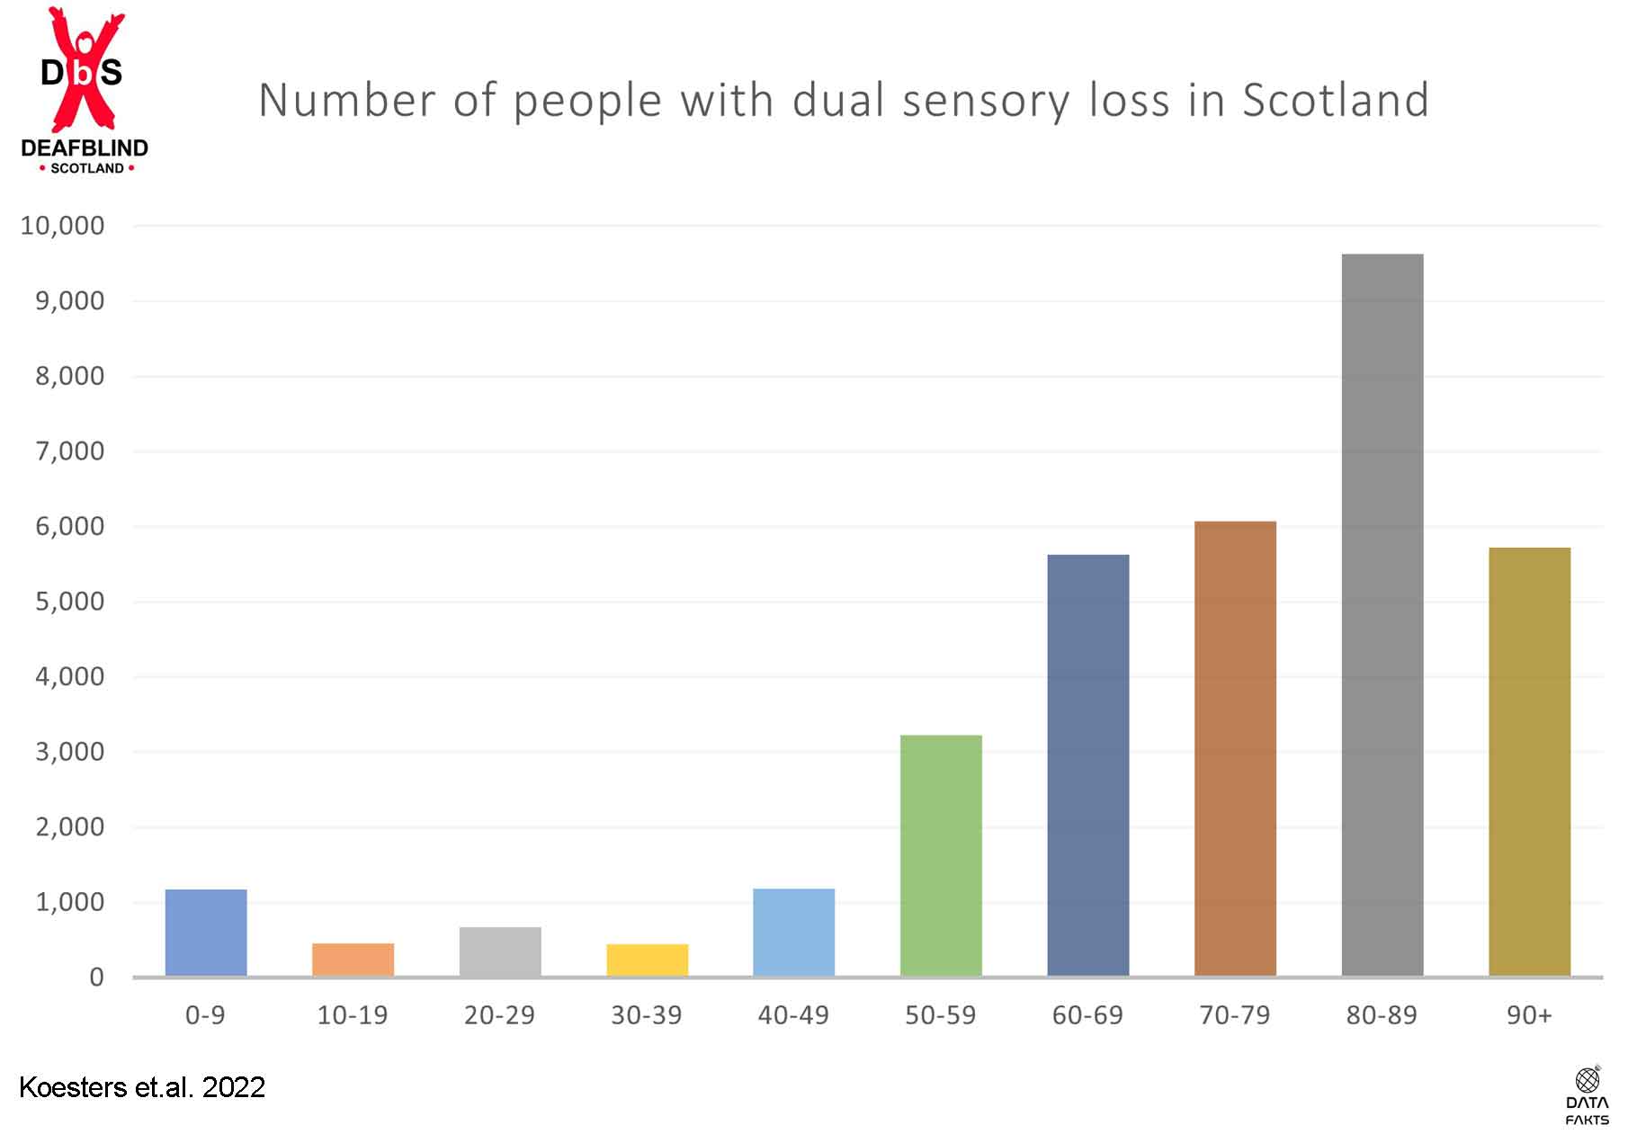

Figure 1: Estimated number of people with dual sensory loss/deafblindness in Scotland. Generated using upper estimates from Robertson and Emerson (2010). Percentage values divided into age groups and multiplied by the Scottish Government’s latest population estimates.

Figure 2 – Estimated future projection of prevalence figures for deafblindness in Scotland

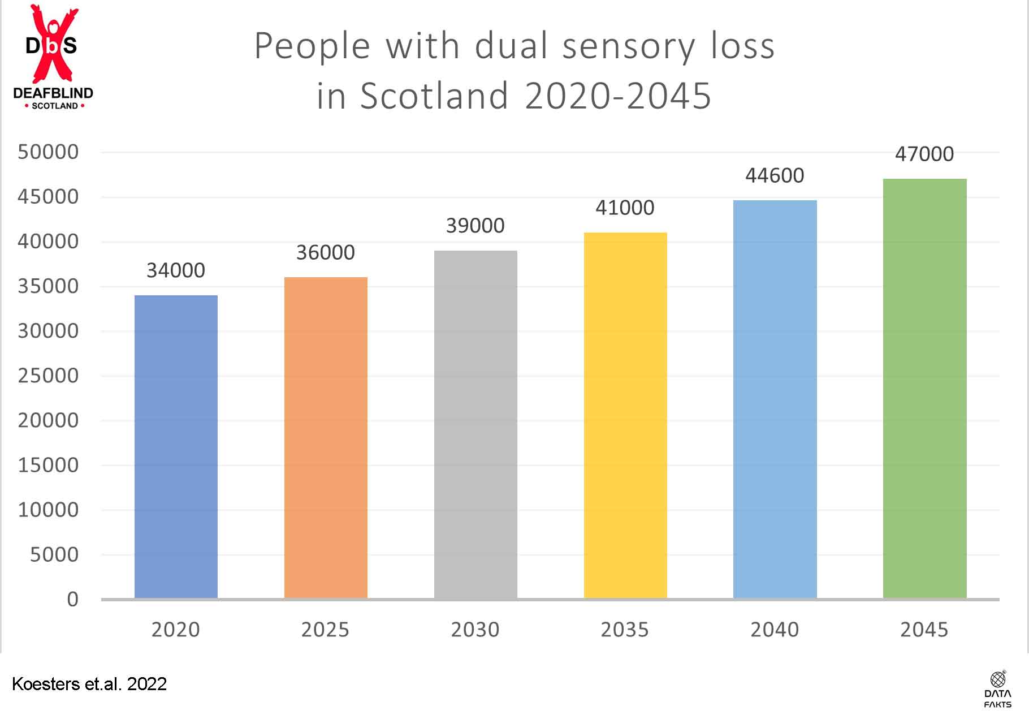

Figure 2: Estimated number of people with dual sensory loss/deafblindness in Scotland projected over a 25-year period. Generated using upper estimates from Robertson and Emerson (2010) and the Scottish Government’s latest population estimates.

Appendix 2 What is deafblindness?
The definition of deafblindness is problematic. While there is no global consensus, the Nordic definition, revised in June 2016, is widely accepted. Recently endorsed by the World Health Organisation’s International Classification of Functioning, Disability and Health (ICF), the definition is noted below:

Deafblindness is a combined vision and hearing impairment of such severity that it is hard for the impaired senses to compensate for each other. Thus, deafblindness is a distinct disability. (The Nordic Definition of Deafblindness)

The definition goes on to state:
To varying degrees, deafblindness limits activities and restricts full participation in society. It affects social life, communication, access to information, orientation, and the ability to move around freely and safely. To help compensate for the combined vision and hearing impairment, especially the tactile sense becomes important. (The Nordic Definition of Deafblindness).

In terms of Scotland, for the purposes of this paper, the description of deafblindness as set out in the Deafblind Scotland toolkit is applied, and is noted below:

Deafblindness is the combined loss of both vision and hearing. For some people this may be a complete sensory loss whilst for others there may be some residual sight or hearing that can be used. Deafblindness has been defined in several ways but in understanding the impact on people’s lives it is important that it is not thought of in terms of two single sensory losses as this uniquely disabling condition is greater than the sum of its parts.

When an individual experiences a single sensory loss or are Deaf from birth they often cope by making the best use of their other senses however, with a dual sensory loss this coping strategy becomes less effective.

The combination of sensory losses can result in significant difficulties in areas of everyday life, including:

‘Communicating and building and maintaining relationships (social connectedness);
‘Mobility and navigating the physical environment’ and ‘accessing information and learning’.

Deafblindness can happen at different stages of life and the age of onset of a person’s visual impairment and hearing loss (or Deafness) can have a profound impact on the consequences of deafblindness. This is particularly the case in relation to communication and language development. It therefore can be important to distinguish between: -

Congenital deafblindness – where a child is born Deaf with a visual impairment or where a child acquires hearing loss and a visual impairment at an early stage in life before the development of language. Over recent years there has been growing understanding of the role that neurological conditions play in congenital deafblindness such as Cerebral Visual Impairment and Auditory Processing Disorders. Occurring at a pre-lingual stage congenital deafblindness requires the child to develop language whilst deafblind. Language development is supported through the co-creation of meaning with a skilled communication partner, applying the bodily-tactile modality.

Acquired deafblindness – where vision and/or hearing loss is acquired during the course of life following language development, where language maintenance or adaption is the focus. An individual may already have one sensory loss and acquire a second during their life or both senses may deteriorate across life.

Usher Syndrome – is a genetic condition which causes hearing loss from birth, and a later progressive loss of vision due to Retinitis Pigmentosa
(RP). There are three types of Usher Syndrome

CHARGE – is a genetic syndrome, each individual will have a varying degree of impairments and medical conditions. Most people with CHARGE will develop hearing impairment, vision impairment, and balance problems, along with life limiting medical conditions from birth.

https://dbscotland.org.uk/wp-content/uploads/2015/08/BSL-TOOLKIT-with-pics-v3.pdf

As has been stated, the Nordic definition is endorsed by the World Health Organisation, has wide support globally and most professionals in the field adhere to the Nordic model.
with the other sense, resulting in a distinct disability’ (Guthrie, et al., 2016).
Around three quarters of all deafblind people are older and have acquired deafblindness as they age. This is a heterogeneous group of people with each individual’s journey to deafblindness being unique. The age of onset of an individual’s sensory loss can have a profound impact on the consequences of deafblindness.

It is important to note that there is shared experience that connects those with congenital and acquired deafblindness. It is easy to assume that those born with deafblindness would have very little in common with those who acquire it later in life, but this is not the case. For example, a 2017 study involving long term care residents who use a self-management programme, it was found that:

“Older [deafblind] adults feel threatened in their existence as a social human being; they feel unable to reach out to others, to be aware of what is happening in their environment, or to discuss and negotiate about the care they receive” (Roets-Merken).

Interestingly, this study also highlighted that, care home residents living with deafblindness reported similar experiences to that of young adults with congenital deafblindness. Despite having very different experience of life with dual sensory loss, both groups report feelings of being socially isolated and being out of control of their environment (Roets-Merken). These studies serve to highlight that whilst it might look as congenital and acquired deafblindness are two disparate groups, in reality, key aspects unite them.

Appendix 3

Declaration on the rights of deafblind people
Adopted by the European Parliament, 1 April 2004.

...deafblind people should have the same rights as are enjoyed by all EU citizens; these should be enforced by appropriate legislation in each Member State and should include:

- The right to participate in the democratic life (of the European Union)
- The right to work and access training, with appropriate lighting, contrast, and adaptations
- The right to person centred health and social care
- The right to lifelong learning
- The right to receive one-to-one support where appropriate from communicator guides, deafblind interpreters and/or intervenors

Bibliography

Ask Larsen, F., & Damen, S. (2014). Definitions of deafblindness and congenital deafblindness. Research in Developmental Disabilities, 35 (10). 2568-76.
https://doi.org/10.1016/j.ridd.2014.05.029

Dammeyer, J. (2012). Identification of congenital deafblindness. British Journal of Visual Impairment, 30, 101–107. https://doi.org/10.1177/026461961244388

Fellinger, J., Holzinger, D., Dirmhirn, A., Van Dijk, J., & Goldberg, D. (2009). Failure to detect deaf-blindness in a population of people with intellectual disability. Journal of Intellectual Disability Research, 53, 874–881. doi:10.1111/j.1365-2788.2009.01205.x

Ravenscroft, J., & Damen, S. (2019). Editorial. British Journal of Visual Impairment, 37(2), 77-80.https://doi.org/10.1177/0264619619847016

Robertson, J., & Emerson, E. 2010. Estimating the number of people with co-occurring
vision and hearing impairments in the UK. Lancaster: Centre for Disability Research,
Lancaster University.

Roets-Merken, L., Zuidema, S., Vernooij-Dassen, M., & Kempen, G. (2014). Screening for hearing, visual and dual sensory impairment in older adults using behavioural cues: A validation study. International Journal of Nursing Studies, 51, 1434–1440. DOI: 10.1016/j.ijnurstu.2014.02.006

World Federation of the DeafBlind. (2018). At risk of exclusion from CRPD and SDGs implementation: Inequality of persons with deafblindness. New York, NY. https://wfdb.eu/wfdb-report-2018/

Reports:

https://dbscotland.org.uk/wp-content/uploads/2015/08/BSL-TOOLKIT-with-pics-v3.pdf

Koesters, N., McMenemy, A. & Johnson, C. 2022. Prevalence rates for those with Dual Sensory loss and Dementia in Scotland. https://www.datafakts.com/dual-sensory-loss-and-dementia-in-scotland/

https://www.europarl.europa.eu/doceo/document/TA-5-2004-0277_EN.html

https://assets.publishing.service.gov.uk/government/uploads/system/uploads/attachment_data/file/388198/Care_and_Support_for_Deafblind_Children_and_Adults_Policy_Guidance_12_12_14_FINAL.pdf

https://nordicwelfare.org/en/disability-issues/the-deafblind-field/

https://suitceyes.eu/wp-content/uploads/2021/02/SUITCEYES-Law-and-Policy-report-Germany-1.pdf

https://www.sehd.scot.nhs.uk/mels/HDL2007_20.pdf

The treaties that will be incorporated are: the International Covenant on Economic, Social and Cultural Rights; the Convention on the Elimination of All Forms of Discrimination against Women (CEDAW); the Convention on the Elimination of All Forms of Racial Discrimination (CERD); and the Convention on the Rights of Persons with Disabilities (CRPD).

